**Resume**

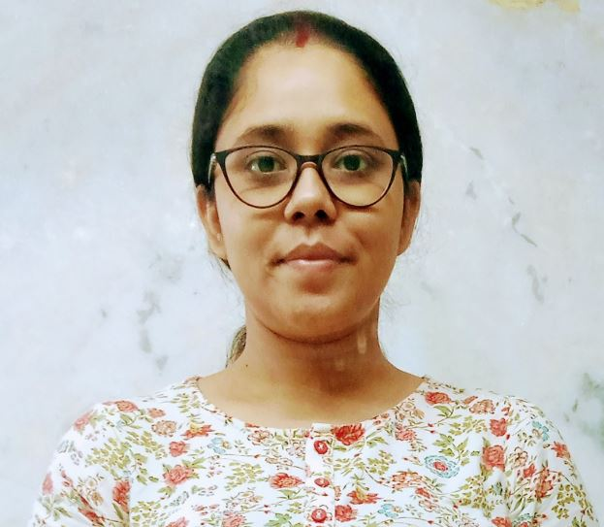

**Puja Bhattacharjee**

Mobile No. 9836576732

Email: officialpuja90@gmail.com



Career Objective:

To secure a promising position in an organization where I can get exposed to opportunities to learn, grow and prove my potential to achieve betterment of my own and people around as well.

Educational Qualifications:

|  |  |  |  |  |
| --- | --- | --- | --- | --- |
| * D.El. Ed -West Bengal Board of Primary Education; 2020 -2022 (82%) * Master of Arts: Archaeology - University of Calcutta; 2010-2012 (55%) * Bachelor of Arts (H): Sanskrit - University of Calcutta; 2007-2010(49%) * Higher Secondary: W.B.C.H.S.E.; 2007(69%) * Secondary: W.B.B.S.E.; 2005; (68%)  |  |  | | --- | --- | | ***Employment Details:***  ***Greenfield Academy, Rajarhat, Kolkata***  ***12th April 2021-7th Feb 2022***    ***Position: Assistant Teacher***  ***Responsibilities:***   * Responsible for students of standard VI & IV (as Class Teacher in two different sessions). * Regular classes taken of multiple subjects [HISTORY & CIVICS (Class VII, VIII & IX), VALUE EDUCATION (Class VIII), ENGLISH LITERATUE & LANGUAGE (Class II, IV & VI]). * Processing of Exam Papers & Marksheets. * Conducting PTMs.     ***Chemex India***  ***18th June 2018 – 7th January 2020***  ***Position: Sales Co-ordinator***  ***Responsibilities:***   * Responsible for credit & collection of Kolkata Metro Distribution Branch for Tata Salt, Pulses, Soda & Detergent. * Regular follow up with sales team & stockists as per sales portfolio. * Maintaining follow up over mail to make every detail documented. * Processing and generating reminder letters, bills, outstanding, monthly statements and claims. * Use of SAP for Kolkata Metro to keep track on order range improvisation and growth.   ***Sabbatical (Feb 2017 – May 2018)***  I was on sabbatical leave & left job to focus on studies for the civil services exam & during that time my father got a minor stroke, so I had to move back to my home town. There I used to provide tuitions to support my family  ***Chemex India***  ***January 2015 – February 2017***  ***Position: Sales Co-ordinator***  ***Responsibilities:***   * Visiting Stockists if required and maintain relationship with regular customer along with the TSIs. * Supporting tele communication with mother company and stockists when require. * Ensuring payment is collected in given time by customer. * Investigating and resolving queries relating to non-payment of invoices. * Order and dispatch flow check-ups and reporting on daily basis. * Account reconciliation and complete documentation.   ***Employment Details: (Cont.)***  ***Just Dial Limited***  ***December 2013- July 2014***  ***Position: Customer Service Executive***   * Responsible for Customer Service of Kolkata Branch. * Regular follow up with individual & business customer as per portfolio. * Maintaining follow up over mail to make every detail documented. * Meeting debtors if required and maintain relationship with regular customer. * Supporting tele calling team & agencies as and when require. * Lining up to Sales and Post Sales department to get the contract renewed. * Ensuring smooth service in given time by customer. * Processing and generating reminder letters and monthly statements. * Investigating and resolving queries relating to existing and new customers. * Legalizing with the sales team to resolve the outstanding queries. * Account reconciliation.   ***Thinktel Solutions India Private Limited***  ***December 2012 – July 2013***  ***Position: Relationship Manager (Corporate Service)***  ***Responsibilities:***   * *Meeting up with the client as SPOC on basis of accounts allocated.* * *Maintaining relationship to retain them.* * *Finding out customer’s challenges.* * *Resolving the challenges with interpersonal skills & customer service skills.* * *Coordinating with customers via mail on daily basis.* * *Coordinating with concern team to get the update of all Service Requests.* * *Looking after the Customer Service Request being done within SLA by concern team.* * *Making sure customer gets proper reply for their requests and quarries via mail.* * *Ensuring payment is collected in given time by customer.* * *Update proper feedback to reporting manager on all accounts.* |  | |  |  | |

Certification and other technical knowledge:

* Diploma in Information Technology.
* MS Word Proficiency
* MS Excel

Core Competencies:

* Good Learner
* Dedicated
* Diligent
* Adaptable

Personal Information:

Date of Birth : 23.05.1990

Nationality : Indian

Gender : Female

Marital Status : Married (To Mr. Trideb Choudhury)

Permanent Address : 90, B.L Das Lane, English Bazar, Dist. -Malda, West Bengal. Pin-732101

Languages known : English, Hindi, Bengali.