**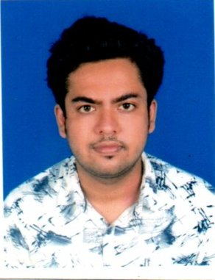BIO DATA**

**NAME**: - **SOUVIK KUMAR SINHA**

**CURRENT & PERMANENT ADDRESS**

**ADDRESS**:- REGENT PARK

**P.O. + DIST:-** MALDA

**P.S.:**- ENGLISH BAZAR.

**PIN:-** 732101

**CONTACT NO**: - 9051834971

**EMAIL ID: -** [**souvikkumar5678@gmail.com**](mailto:basumalda20@gmail.com)

**PERSONAL PROFILE**

**FATHER’S NAME** :- BIPLAB KUMAR SINHA

**DATE OF BIRTH**: – 28/01/1997

**SEX:** – MALE .

**CATEGORY** :- GENERAL

**NATIONALLY: -** INDIAN.

**MARITAL STATUS: -** UNMARRIED.

**LANGUAGES KNOW**: - BENGALI, ENGLISH & HINDI.(Read & Write)

**ACADEMIC QUALIFICATION**

|  |  |  |  |
| --- | --- | --- | --- |
| **S.L** | **EXAMENITION**  **PASSED/DEGREE/DIPLOMA** | **BOARD / UNIVERSITY** | **PERCENTAGE OF MARKS** |
| 1 | MADHYAMIK | W.B.B.S. EDUCATION | 82.28% |
| 2 | HIGHER SECONDARY | W.B.C.H.S. EDUCATION | 60% |
| 3 | B.Sc (H) in Microbiology | ADAMAS UNIVERSITY | 6.34 CGPA/ 63.23% |
| 4 | B.Ed | Satis B.ed College | 83.05% |
| 5 | Msc | Radha Govind University | 78% |
| 6 | Bihar stet |  | Qualified |

* **INTERNSHIP : One Month Internship on Food Microbiology ( Quality Control of Milk ) From SHRM BIOTECHNOLOGY PVT. LTD.**
* **Specialization : CERTIFICATE COURSE IN INFORMATION TECHNOLOGY APPLICATION**
* **[ 6 MONTH DURATION COURSE ] FROM MALDA SADAR YOUTH COMPUTER TRAINING CENTRE**
* **PROJECT REPORT : INVESTIGATION THE RELATIONSHIP BETWEEN PLAYING VIDEO GAMES AND ATTENTION AMONG YOUNG ADULTS - A Pilot Survey In Adamas University Campus . [ Unter Mentorship of Dr. NELOY KR CHAKRABARTI \_ neloykumar@gmail.com ]**
* **SEMINAR : 1)INFLUENCE OF MICROBIOLOGY IN HUMAN HEALTH**

**2) IMPACT OF MICROBES ON ENVIRONMENT AND SOCIETY**

**Specialization :**

* **One month laboratory Apprenticeship program (internship) in medical microbiology from Sneho Diagnostic Centre, Malda . [ Under guidance of Dr. Partha Sarathi Roy. ( Professor of govt. Medical college)]**
* **Certificate of Participation on "Application of Biometrical Techniques in Plant Breeding Selection", organised by the Department of Agricultural Sciences, Radha Govind Unversity, Ramgarh .**
* **Teaching experience - More than 5 years .**
* **Preference of Subject for teaching - Biology ( upto class 12 ) + Neet level**

**Physics ( upto class 10 )**

**Chemistry ( upto class 12 )**

**Math ( upto class 10 )**

**IMG_20250318_0002.jpg**

**DATE-18/03/2025**

**SIGNATURE**