CURRICULUM VITAE

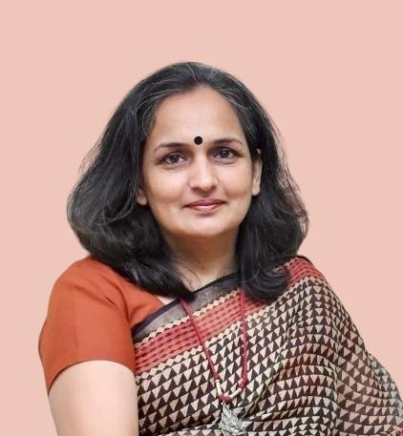**CONTACT INFORMATION:**

Shiva Bishnoi

23C, CGO Residential Complex

Sector 38 A

Chandigarh 160036

Email: bishnoishiva@gmail.com

Mobile: 8826716444

**OBJECTIVE:**

Dedicated and experienced educator with over a decade of expertise, seeking a dynamic position as a Subject Matter Expert. With years of experience as Academic Coordinator and English teacher, I aim to apply my strong language skills to deliver high-quality academic content, including reports, essays, assignments etc. My expertise in language and communication, combined with a keen understanding of academic writing, will enable me to produce clear, well-researched, and impactful content tailored to academic standards and specific subject requirements. I am committed to consistently providing exceptional written material that meets the unique needs of each project, while adhering to deadlines and maintaining high professional standards.

**SCHOLASTICS:**

* University Grants Commission NET for Lectureship 2000
* Agricultural Scientists Rectt. Board NET for Lectureship 2004
* Rajasthan Agri. University, Bikaner; M.Sc. (F&N) 2000
* Rajasthan Agri. University, Bikaner; B.Sc. Home Sc. 1998
* I.A.S.E. University, Sardarshahar (Raj); M.A. (Ed) 2008
* Jammu University, Jammu; B.Ed. 2003
* British Council; Spoken English Upper Intermediate 2009
* IIM Bangalore; Women Startup Program 2022-2024
* India SME Forum; Orientation Program for Exports 2024

Contd/-

**EXPERIENCE:**

* Lead Mentor (Year 1 to 6), Activity Coordinator and SOF/ACER Coordinator at Mayoor School, Sri Ganganagar.
* Coordinator for Cambridge Assessment International Examination (CAIE) & ISA by British Council.
* TGT (English), Year 7 to 10 at Mayoor School, Sri Ganganagar.
* Lecturer of Home Sc. (F&N) at SGN PG Khalsa College, Sri Ganganagar. Subjects for teaching were Biochemistry, Food Science and Therapeutic Nutrition.
* Lecturer of School Management & Statistics at Himalayan B.Ed. College, Rajouri (J&K).
* TGT (English) at Himalayan School, Rajouri (J&K) and Merry Angel’s Public School, Sri Ganganagar.

**STRENGTHS:**

* Good Communication Skills.
* Good Inter Personal Relationship.
* Open To Shoulder Responsibilities.
* Dedicated and Hard Working.

**REFRENCES:**

* Dr Roiana Khan, Head of School, Fort City School, Vizianagram (Andhra Pradesh), Mobile No. 9557911979
* Dr Aanieetaa Vaissnava, Principal, Vidya Jain Public School, Rohini, New Delhi, Mobile No. 9810075227